**Training ML Model on IBM Watson**

**TEAM ID:** PNT2022MID23390

**PROJECT:** University Admit Eligibility Predictor

1. **Setting up Watson Studio for running Jupyter notebooks**

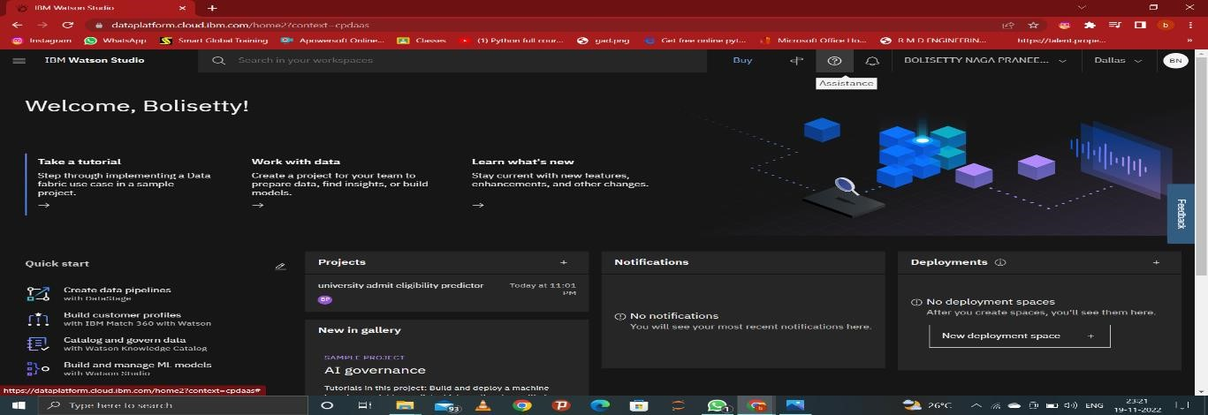

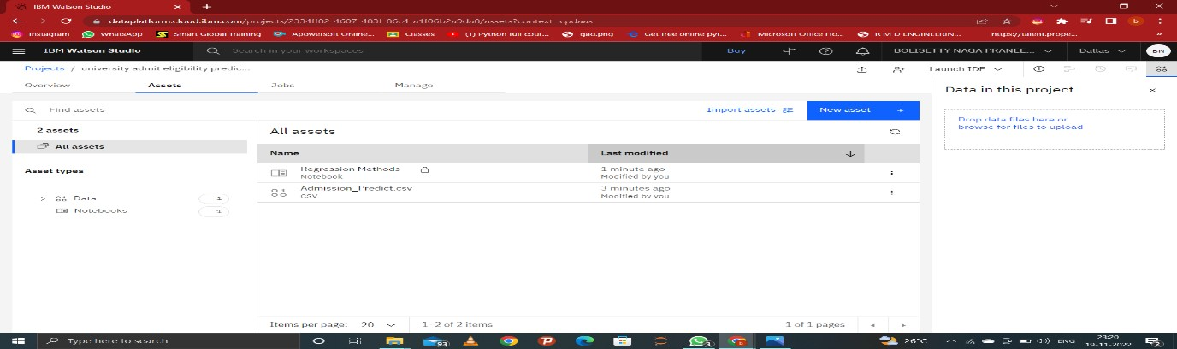

1. **Training and saving the model in IBM Watson Machine Learning Service**

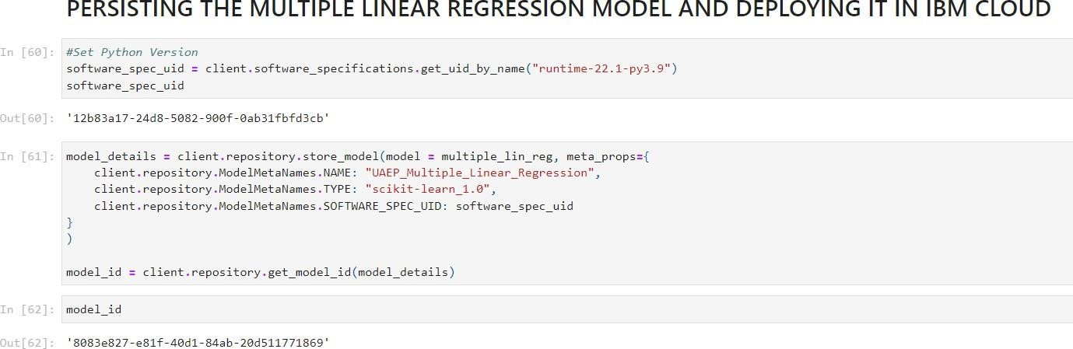

**Assets:**

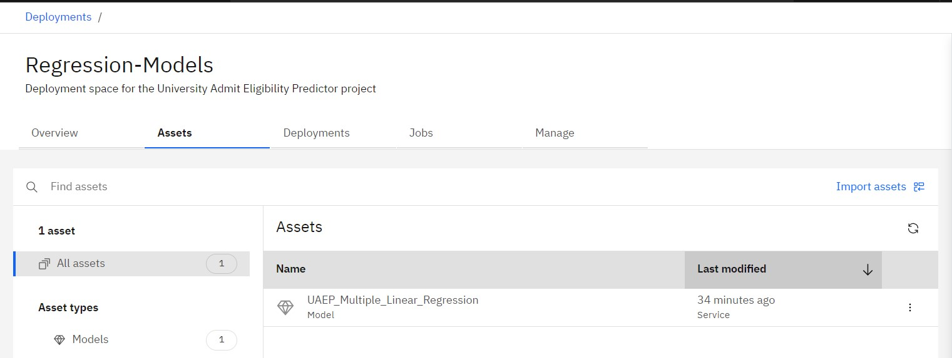

**Deployments:**

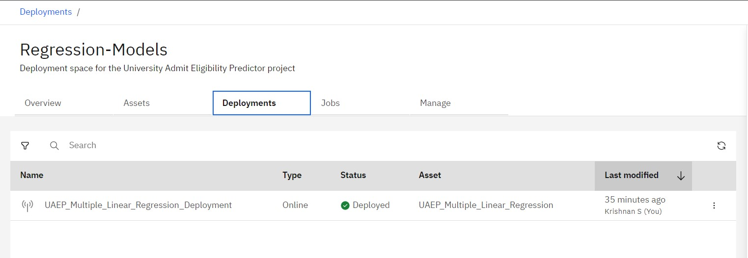

1. **Testing the created model using the API created for the deployed model:**

